2021

Enhanced

Online Banking

Guide



October 2021

**Enhanced Online Banking Experience**

We are excited to announce that on ***Sunday, October 24, 2021***, we will be releasing an enhanced Online Banking experience! To help you prepare for these changes, we’ve put together an overview of the changes and exciting new features coming your way.

**NOTE:** Colors shown in the images may not represent the colors displayed in the Online Banking experience release in October.

**Table of Contents**

* Enhanced Design
  + Overview Page
  + Accounts Page
  + Move Money
  + My Spending
* New Features

* + Widgets and Personalization
  + *Quick*View
  + Favorites
  + Account Groups

**Enhanced Design**

**Overview Page**

* The **Home** page has now been updated to the **Overview** page. Here’s a quick overview of the changes you will see:
  + The new page has 2 columns – Accounts and Widgets.
  + Your accounts are listed in the left column (both BankNorth accounts and Outside accounts.
  + The new column on the right side of the page displays widgets available to you.
  + Easily access BankNorth **contact information** by clicking the phone icon Icon

    Description automatically generated anywhere you are during your Online Banking session.
  + **Alerts & Messages** are still accessible from the top of any page within Online Banking by clicking the bell or email icons. Icon

    Description automatically generated
  + **Services & Settings** previously accessed by clicking the “Contact Us” link is now accessible by clicking the gear icon Icon

    Description automatically generated at the top of any page within Online Banking. The options will display in a dropdown when the icon is clicked.
  + **Spendable Balance** is now located on the right side of the Overview page in the widgets columns as its own widget.
  + **Log Out:** The log out option is now displayed under the nickname dropdown where your profile nickname is displayed along with your Profile Settings.

|  |  |
| --- | --- |
| **Contact Information** |  |
| **Alerts** |  |
| **Messages** |  |
| **Services & Settings** |  |
| **Log Out**  **& Profile Settings** |  |

**Accounts Page**

* The accounts page has been designed to display more information in an easier to view format.
* Links previously shown on the right side at the top of the page are now displayed as sub-tabs along with the existing Activity sub-tab.
* Primary account balances will display at the top right corner of the page.
* Additional details regarding the accounts can be accessed by clicking the link (*More Details*) under the Account Name/Nickname on the top left of the page.

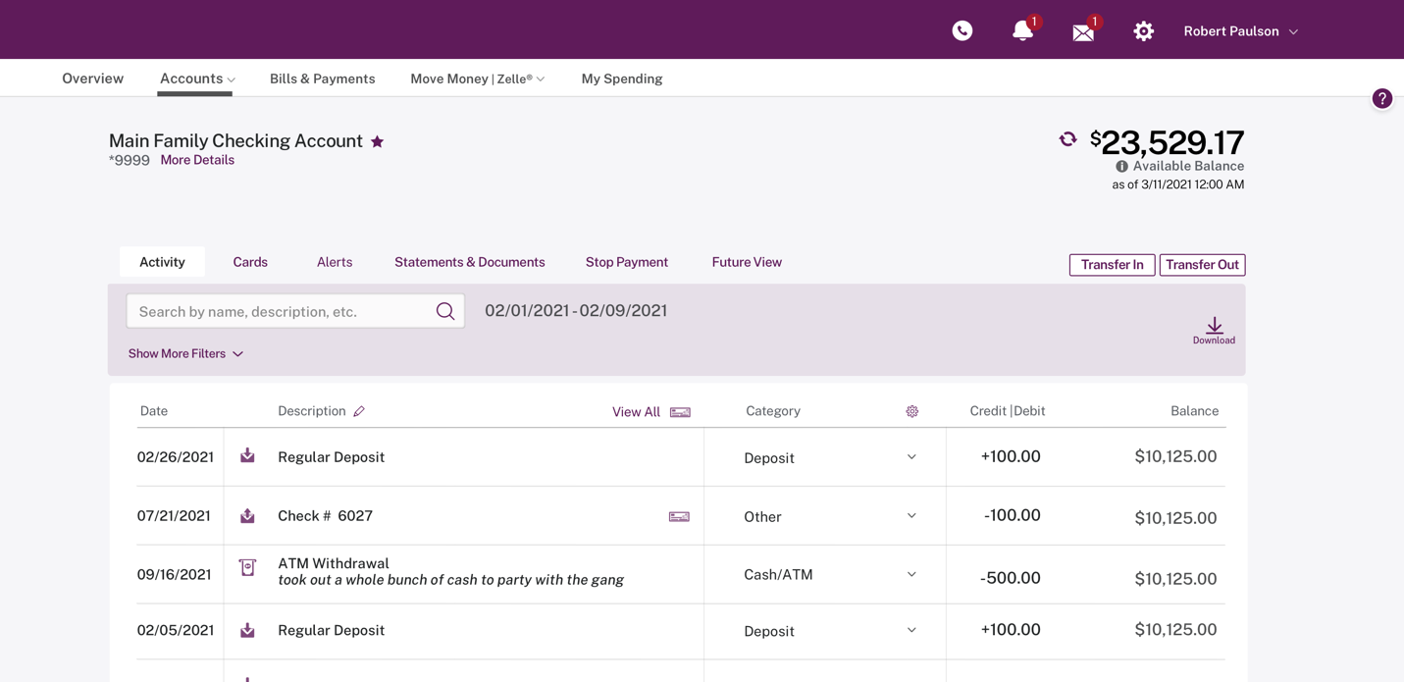

**Move Money**

* The Move Money page where you conduct transfers contains the same functions and options you are used to using each day.

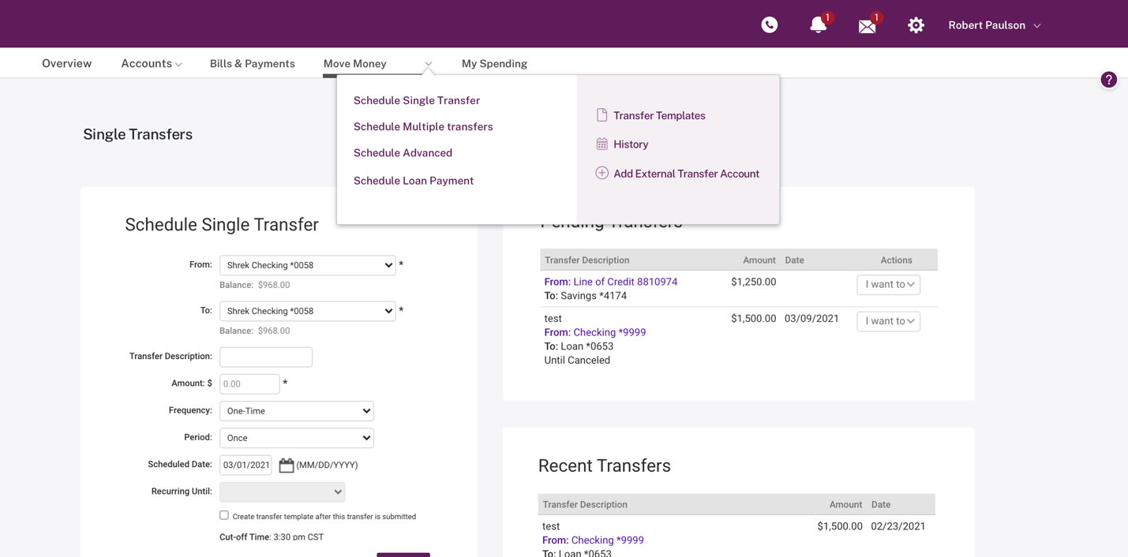

**My Spending**

* The Category Watch widget (just as on the Overview page) has a new design using bars for the day-to-day progress.

**New Features in your Enhanced Online Banking experience!**

**Widgets (Overview page)**

* Provides direct access to more information and data.
* You can personalize the information and access to features you use most and even reorder and hide most widgets.

**Widgets Supported**

* Spendable Balance *(for consumers only)*
* My Spending *(for consumers only)*
* Category Watch *(for consumers only)*
* Pending Transfers *(for consumers and businesses)*
* Unread Messages *(for consumers and businesses)*

**QuickView**

* Allows you to move from account to account and view recent activity and available actions without ever leaving the Overview page.
* Displays the most recent 5 transactions on an account (both BankNorth and Outside).
* Clicking a transaction displays the transaction modal for quick editing of the transaction on BankNorth accounts.

**Accounts Favorites (Consumers Only)**

* Favorites allow you to create a subset of your accounts to view by default or at any time versus the *All Accounts* list.
* You are now able to select Outside accounts to be included in your list of Favorite accounts.

**Account Groups (Businesses Only)**

* Ends the frustration of searching for specific related accounts in a long list of accounts.
* You can create a subset of accounts (both BankNorth accounts and Outside accounts) that can be used for viewing only those accounts on the Overview page, as well as using those groups for Cash Management features in the future.

